Ridge Meadows Coaches Plan Booklet C



Keys to a Great and Productive Practice

Always start with a warmup and some free play, this lets the kids have fun and interact with teammates. This also allow kids to get use to the ball, how it moves, bounces, and feels.

After 5 mins of free play make the team run; either lines or around half rink or full rink if you have it. This gets them ready to listen and puts their mind on the practice after the free play.

Once the run is done call the team together to have a quick chat and explain the next drill. Do not take too long with the team chats as floor time is always a premium. Also, you want to keep the players attention. If players have questions tell them to go to the back of the line and watch those who know what to do.

Practices work best when players burn their energy early and then you can slow it down and focus on strategy drills towards the end of practice.

Keep the practice up tempo and move quickly through drills. Have assistant coaches move balls and cones between drills, while you explain the next drill. Use your assistant coaches as much as you can to correct and keep drills moving.

Using Practice Plans

Practice plans are sorted into warm up, skill improvement, and strategy. Each week the practice should progresses into more complicated systems. Some drills are a progression from the previous week. They do not need to be done in order, if your team is struggling in a certain facet of the game then feel free to use that drill. Drills can also be tweaked based on team needs and skill level

Warm Up Drills

Warm Up Drills

Skills

Skills

Skills

Strategy

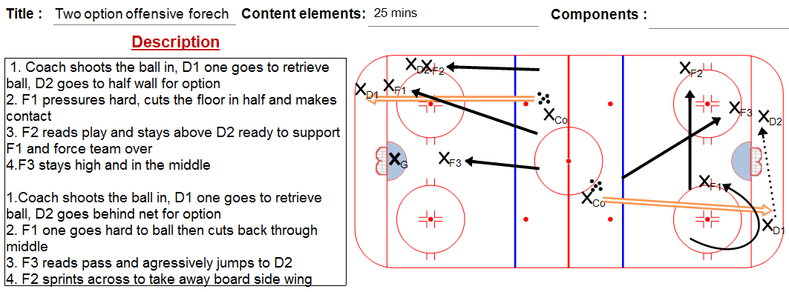

Strategy

Full Floor Drills

Full Floor Drills

